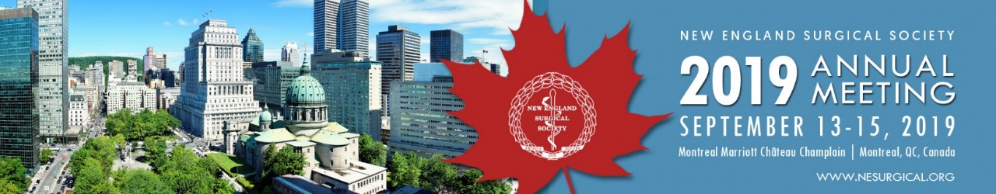

MEETING REGISTRATION Form
PLEASE AUTO FILL FORM OR PRINT:

Name: NPI #:
National Provider Identifier Number
Institution: SPECIALTy:

Address:

City: State: Zip: Country:

Phone: Fax:

E-Mail (required to receive confirmation):

NAME OF SPOUSE/GUEST (only if registering):

REGISTRATION FEES regular rate Quantity

(After August 12)
All fees below are quoted and payable in US Dollars.
A. NESS Active, Senior, or Associate Member $495
B. NESS Candidate Member $250
C. Non-Member $575
D. Resident/Fellow* $250
Name of Dean/Chief of Service: Dean/Chief of Service Email:
E. Spouse/Guest $250
(Registrations include: Continental Breakfasts, Friday Welcome Reception, and Saturday President’s Reception and Dinner)
F. Family Member (ages 5-12) Free Free Age(s):
(Registrations include: Continental Breakfasts, Saturday Kids Banquet)
G. Family Member (ages 0-4) Free Free Age(s):
(Registrations include: Continental Breakfasts, Saturday Kids Banquet) Total:

Complimentary Sessions/Ticketed Events

GME Committee Session, Saturday, September 14th, 12:15 – 1:15 PM Complimentary
Navigating your Financial Future; A Guide for Trainees and Junior Faculty Quantity:

Optional Tour: Maude Abbott Medical Museum, September 14, 1:30-4:00 PM $40 per person
Includes ticket to Museum and transportation to and from the facility. NO lunch will be provided. Quantity:

Optional Tour: McGill Immersive Interactive Simulation Lab Tour, September 14, 1:30-4:00 PM $50 per person
Includes use of the lab and transportation to and from the facility. NO lunch will be provided. Quantity:

Women in Surgery Pre-Reception, Saturday, September 14th, 6:15 – 7:00 PM Complimentary
Quantity:
Additional President’s Reception & Dinner, Saturday, September 14th, 7:00 PM $130 per person
Quantity:

Payment METHOD
I authorize NESS to charge my credit card registration fees. If paying by credit card please call the administrative offices to provide payment via phone at 978-927-8330. Acceptable forms of payment are MasterCard, Visa, AMEX or by check (US banks only). Checks are payable to NESS.

CANCELLATION POLICY
Cancellations cannot be made via the online website or telephone, but must be made in writing (email, fax, or mail) to the NESS Administrative Offices: 500 Cummings Center, Suite 4400, Beverly, MA 01915, USA. You may contact NESS to email your correspondence. If written notice of cancellation is received on or before August 31, 2019, the registration fee, less a 50 USD administrative fee, will be refunded after the meeting. No refunds will be issued for cancellations received after September 7th. Fees cannot be reduced for partial attendance.
Please return this form via fax to: 978-524-0461, or mail to:
NESS Registration, 500 Cummings Center, Suite 4400,
Beverly, MA 01915, USA.
Signature:

