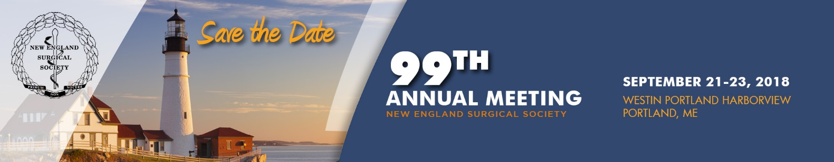

MEETING REGISTRATION Form

PLEASE AUTO FILL FORM OR PRINT:

Name: NPI #:
National Provider Identifier Number
Institution: SPECIALTy:

Address:

City: State: Zip: Country:

Phone: Fax:

E-Mail (required to receive confirmation):

NAME OF SPOUSE/GUEST (only if registering):

REGISTRATION FEES regular rate Quantity

All fees below are quoted and payable in US Dollars.
A. NESS Active, Senior, or Associate Member $495
B. NESS Candidate Member $250
C. Non-Member $575
D. Resident/Fellow* $250
E. Spouse/Guest $250
(Registrations include: Continental Breakfasts, Welcome Reception, and President’s Reception and Dinner)
F. Family Member (ages 5-12) Free Free Age(s):
(Registrations include: Kids “Mad Science” Banquet)
G. Family Member (ages 0-4) Free Free Age(s):

Total:

Ticketed events/Optional Tours

Women in Surgery Luncheon, Saturday, September 22nd, 12:15 – 1:45 PM $30 per person
Quantity: _

President’s Reception & Dinner, Saturday, September 22nd Adult $160
Quantity:

Portland Art Museum/Homer Winslow Studio Tour, Saturday September 22nd, 12:00 – 4:00 PM $32 per person
Includes transportation to/from the Homer Winslow and docent led tour of PAM and Home Winslow (Lunch and drinks on own) Quantity: _

Lucky Catch Lobster Charter, Saturday September 22nd, 2:00 – 4:00 PM –SOLD OUT (Check onsite for availability)
Includes a 90 minute charter tour (Lunch and Drinks on own), ½ mile from hotel and will need to walk or drive to wharf

Payment METHOD
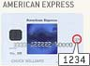
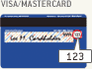
I authorize NESS to charge my credit card the above registration fees. Fees are payable via MasterCard, Visa, AMEX or check (US banks only). Checks are payable to NESS.
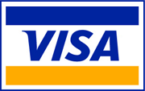 Check (enclosed)

CANCELLATION POLICY
Cancellations cannot be made via the online website or telephone, but must be made in writing (email, fax, or mail) to the NESS Administrative Offices: 500 Cummings Center, Suite 4400, Beverly, MA 01915, USA. You may contact NESS to email your correspondence. If written notice of cancellation is received on or before September 7, 2018, the registration fee, less a 50 USD administrative fee, will be refunded after the meeting. No refunds will be issued for cancellations received after September 7th. Fees cannot be reduced for partial attendance.
Please return this form via fax to: 978-524-0461, or mail to:
NESS Registration, 500 Cummings Center, Suite 4400,
Beverly, MA 01915, USA.
Credit Card #:

Expiration Date: Security Code: (3 digit or 4 digit)

Billing Address:
(If not the same as address listed above)
__________________________________
Signature:

