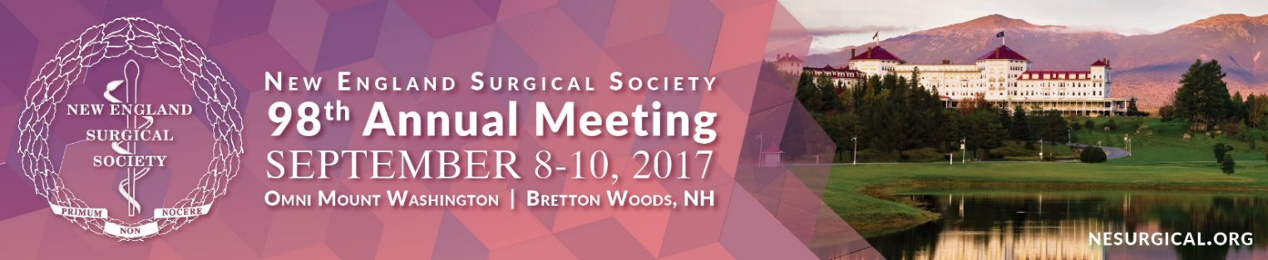

MEETING REGISTRATION Form
PLEASE AUTO FILL FORM OR PRINT:

Name: NPI #:
National Provider Identifier Number
Institution: SPECIALTy:

Address:

City: State: Zip: Country:

Phone: Fax:

E-Mail (required to receive confirmation):

NAME OF SPOUSE/GUEST (only if registering):

REGISTRATION FEES regular rate Quantity

(After August 8)
All fees below are quoted and payable in US Dollars.
A. NESS Active, Senior, or Associate Member $495
B. NESS Candidate Member $250
C. Non-Member $575
D. Resident/Fellow* $250
Name of Dean/Chief of Service:
Dean/Chief of Service Email:
E. Spouse/Guest $250
(Registrations include: Continental Breakfasts, Welcome Reception, and President’s Reception and Dinner)
F. Family Member (ages 5-12) Free Age(s):
(Registrations include: Kids Banquet)
G. Family Member (ages 0-4) Free Age(s):

Total:

*Do you plan to attend the following: Welcome Reception on Friday, September 8th Yes or No:
President’s Reception and Dinner on Saturday, September 9th Yes or No:

Additional tickets/Optional Tours

President’s Reception & Dinner, Saturday, September 9th Adult $160 Quantity:

Mount Washington Cog Railway Tour, Saturday September 9th, 12:30 – 3:30 PM $70 per person Quantity: _
Includes transportation to/from the Omni Mount Washington (at 12:00 PM), boxed lunch, and cog railway ticket

Payment METHOD
I authorize NESS to charge my credit card the above registration fees. Fees are payable via MasterCard, Visa, AMEX or check (US banks only). Checks are payable to NESS.
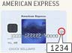
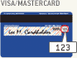
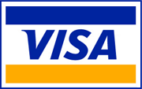 Check (enclosed)
Security Code: (See card image above) Where is your Card Security Code? Your credit card’s security code is a 3- or 4- digit number located on the front or back of your credit card.

CANCELLATION POLICY
Cancellations cannot be made via the online website or telephone, but must be made in writing (email, fax, or mail) to the NESS Administrative Offices: 500 Cummings Center, Suite 4550, Beverly, MA 01915, USA. You may contact NESS to email your correspondence. If written notice of cancellation is received on or before August 25, 2017, the registration fee, less a 50 USD administrative fee, will be refunded after the meeting. No refunds will be issued for cancellations received after August 25th. Fees cannot be reduced for partial attendance.
Please return this form via fax to: 978-524-0461,
or mail to: NESS Registration, 500 Cummings Center, Suite 4400,
Beverly, MA 01915, USA.

Credit Card #:

Expiration Date:

Billing Address:
(If not the same as address listed above)
__________________________________

Signature:

